**Python Code Quality**

Code quality is making code for a program clean and easy to read and understand. Code is read more times than it is written. A plugin/package called a Linter can be used to help analyse a module for clean code. Flake8 is a Python Package that analyses code according to the PEP8 standards.

The below screenshot shows the original code without any re-factoring being performed.

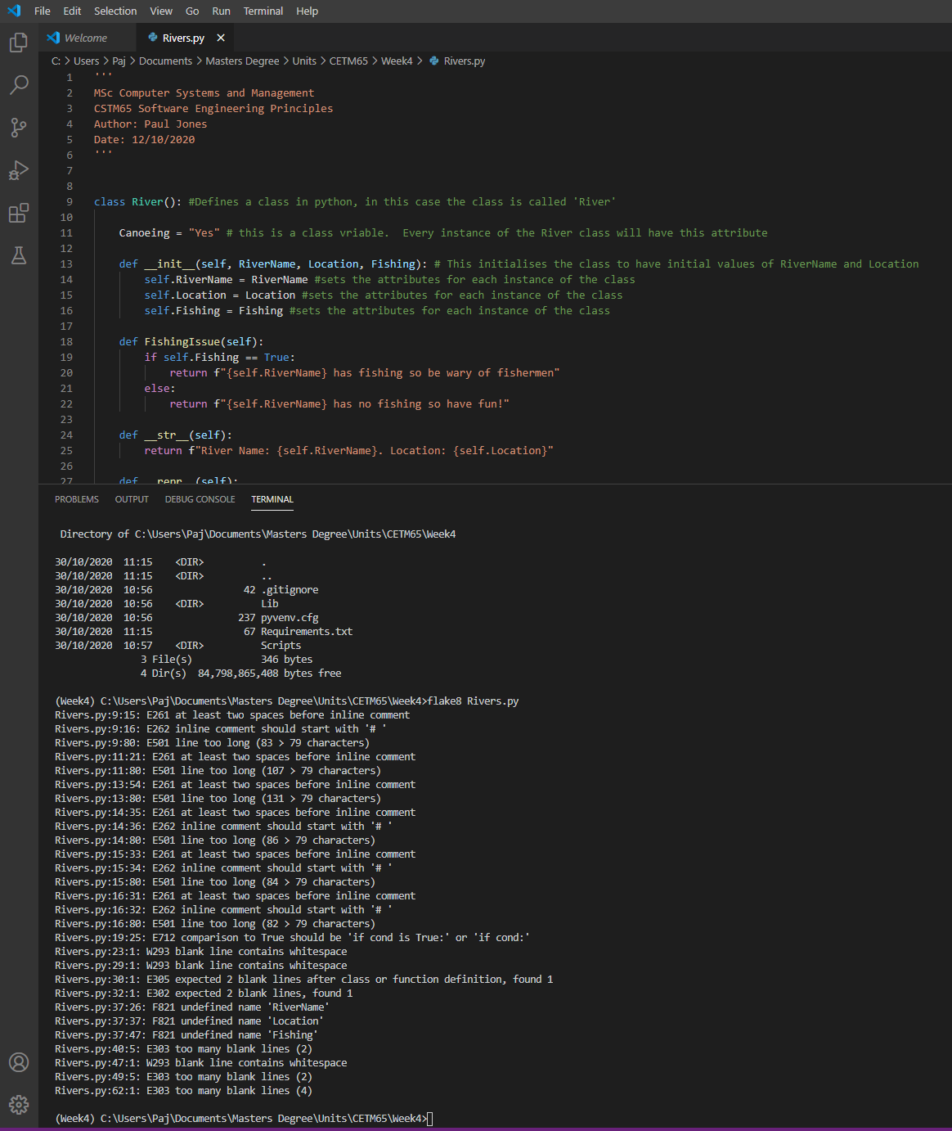

As you can see. There are numerous errors that need to be fixed.

This next screenshot shows the same piece of code after the majority of the errors have been fixed.

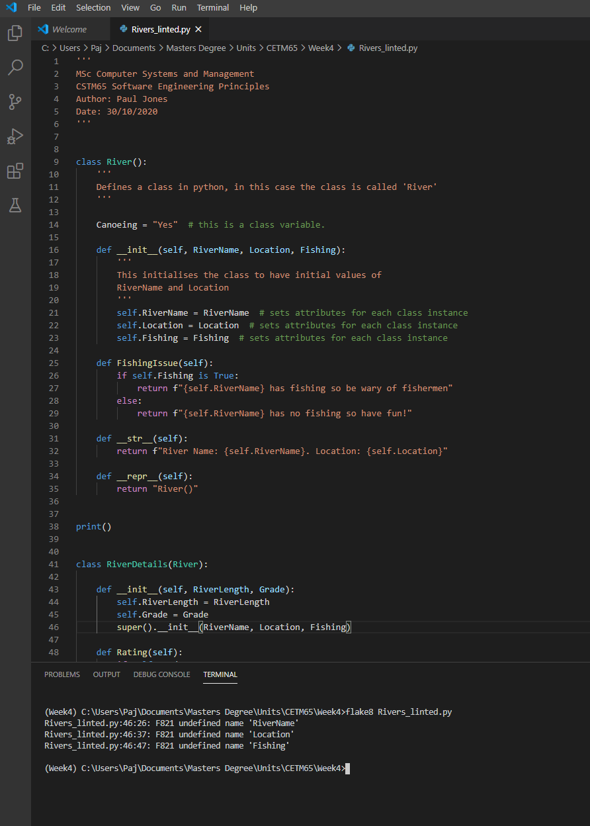

Note that there are still 3 errors.

This final screenshot shows the errors have all been fixed, or Flake8 has been instructed to ignore the error using the ‘# noqa: F821’ comment which tells Flake8 to ignore F821 errors.

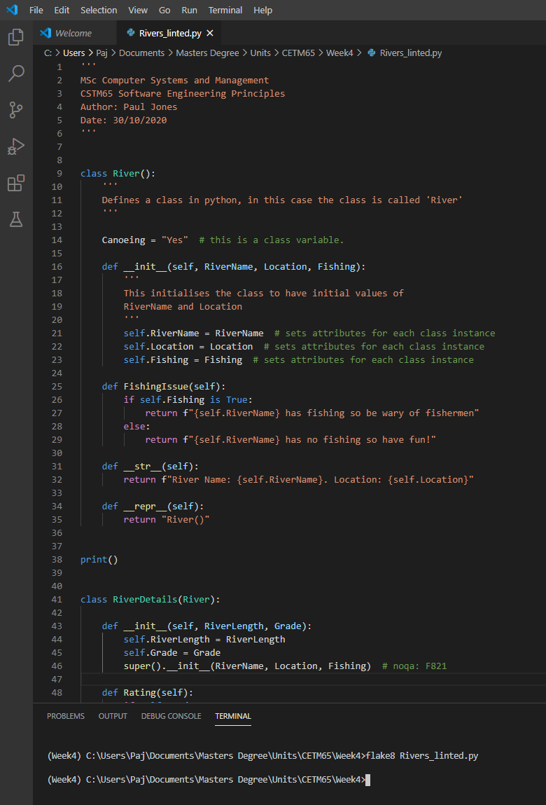

No errors have been detected by Flake8 so the code has passed the PEP8 standards.